**Assignment Day 3**

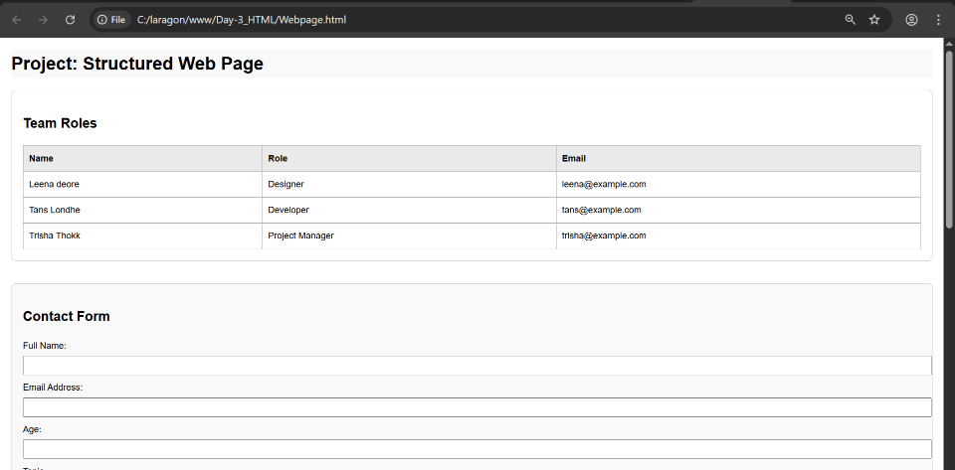

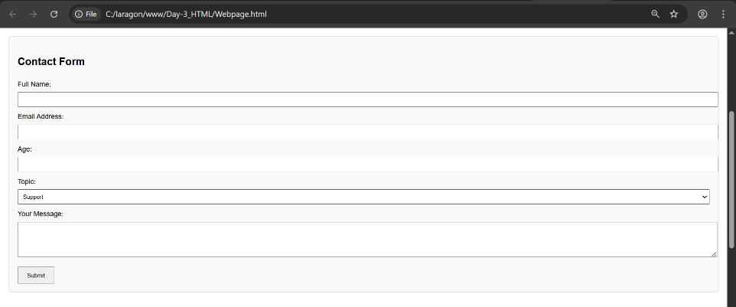

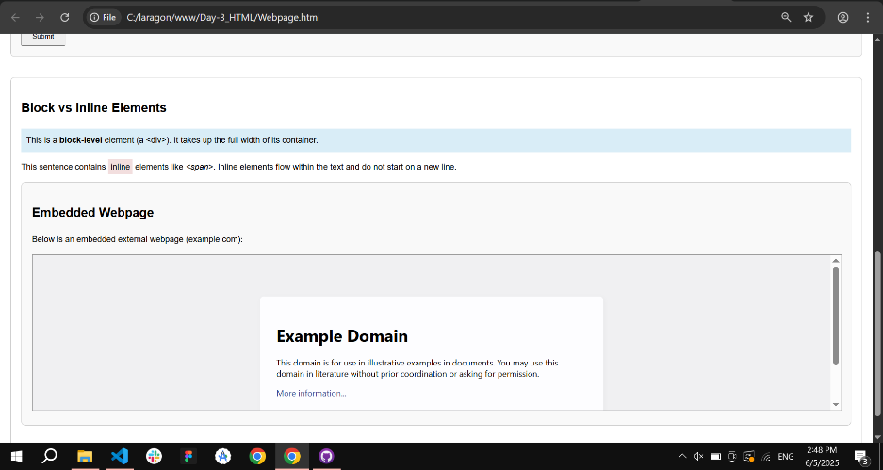

A structured HTML web page demonstrating the use of tables, forms, iframes, block and inline elements, and HTML classes. Designed to showcase foundational web development concepts with clean layout and accessibility in mind.